Marketing Communications Guide

Design, Font type, and core messages of the brand

A guideline to help you note the following key points on Marketing Communications:

Contents

Brand Standards, Logos and Usage 1

Writing Style Guide 2

Font Type 2

Examples of Usage on Web 2

Example of Usage on Product 2

Company Slogan 2

Brand Content and Usage 2

Social Media Content 3

Product Content 3

Package Content 4

Package Image Sample 4

# Brand Standards, Logos and Usage

AeroCool Logo should always be used in Black or White.

White should be the preferred logo color to use since most background assets are darker and it is easier to read the White Logo.

When using just the text – AeroCool must be written with an uppercase ‘A’ and ‘C’.

Always use ‘Oswald’ Font type for the word AeroCool.

# Writing Style Guide

The Style Guide addresses common issues that arise in writing for product and social media publication at AeroCool. It covers usages specific to the brand as well as being a general guide.

## Font Type

Oswald (Regular) – To be used for all headings and slogans across all content. Product webpages, videos and social media. Download Oswald font [here.](https://fonts.google.com/specimen/Oswald?selection.family=Oswald|Roboto)

Roboto – To be used in the body of the text only. Should never be used for headlines and slogans. Download Roboto font [here](https://fonts.google.com/specimen/Oswald?selection.family=Oswald|Roboto).

### Examples of Usage on Web

Be Cool. Get AeroCool.

Save Money. Build Better. (Use on Cases)

Save Money. Power Better. (Use on PSUs)  
Save Money. Cool Better. (Use on Thermal)

Save Money. Sit Better. (Use on Chairs)

Save Money. Work & Play Better. (Use on Desks)

### Example of Usage on Product

Be Cool. Get AeroCool.

AeroCool

## Company Slogan

1. Be Cool! Be Aerocoo!! 2002 – 2019.
2. Be Cool. Get AeroCool. 2019 – current. The company slogan has been updated to add an action element to the main company slogan. It must always be written in the correct font type as stipulated in the guide above.

## Brand Content and Usage

Brand Content is limited to only content created by the in-house design team. No User Generated Content should be used in branding purposes (rare exceptions can be made on a case by case basis).

## Social Media Content

Social Media should always use new content from OneDrive and curate User Generated Content (UGC). For product content, use – infographics, scenario photos, and web layout images.

Keeping the content consistent is key to Social Media messaging. When announcing new products or introducing new materials and information, it is imperative to use the same words as used on the product page content. Do NOT create new copy and words on Social Media messaging.

Social Media design elements should also follow the correct font type as detailed above.

### Example of Social Media Font Type

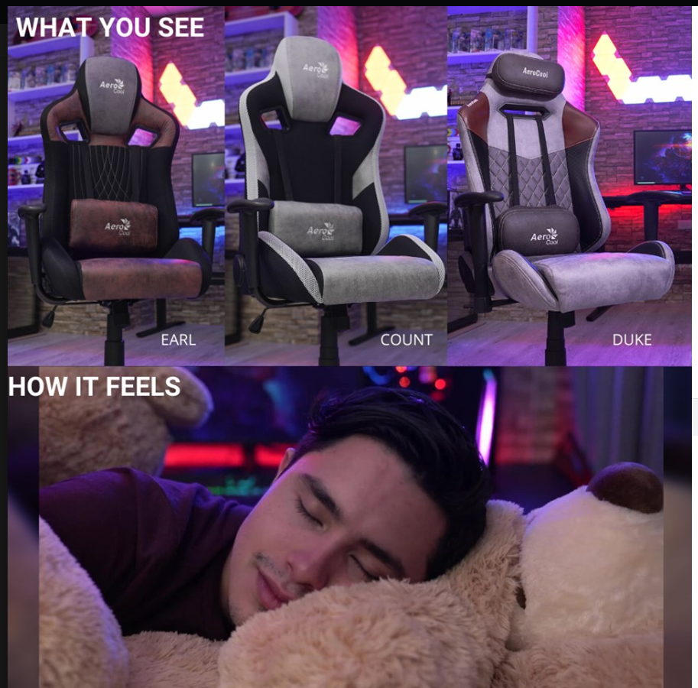Figure 1 Incorrect font type Figure Correct font type

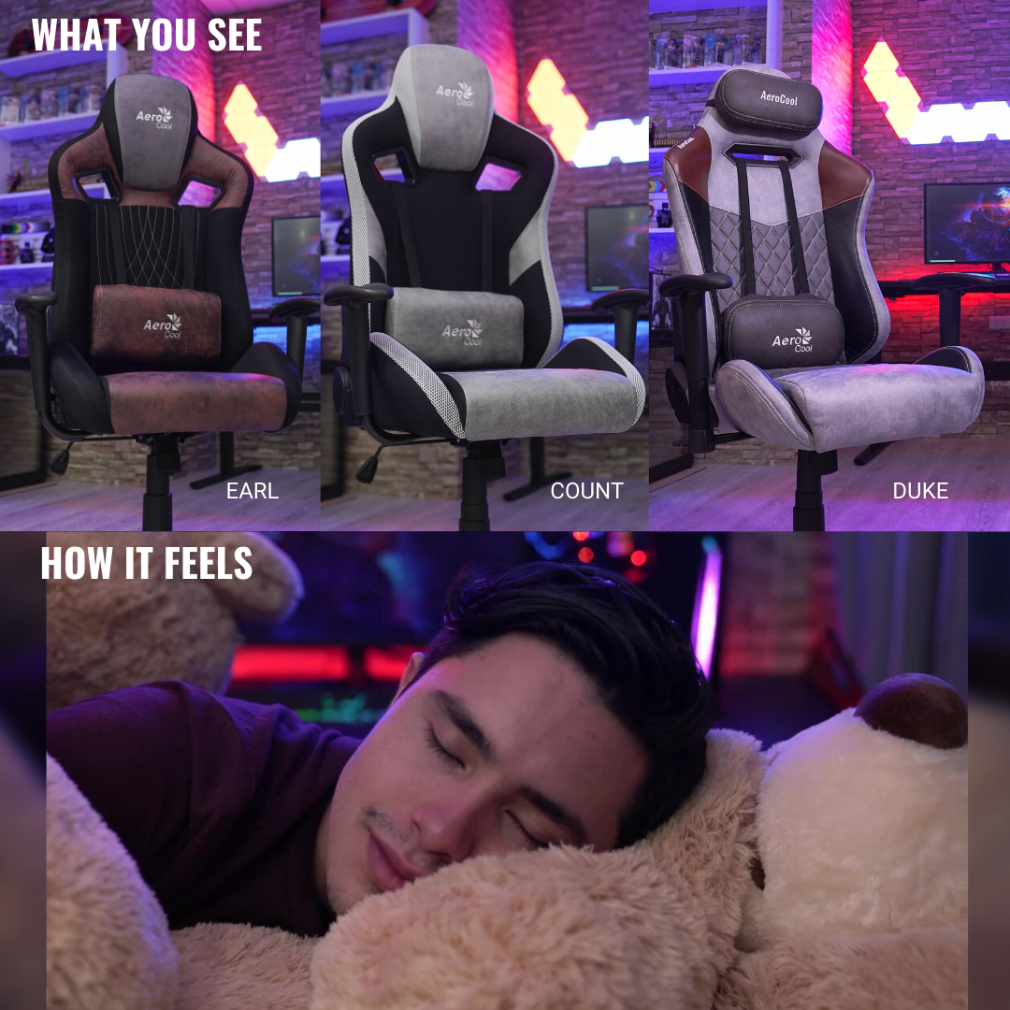

## Product Content

Product Content should always be rehashed and curated from our current Product Content established by the in-house content team. This will be an ever-expanding list and will need new technologies and explanations. These can be accessed on our Cool Tips YouTube or here: <https://aerocool.io/how-to/>

# 

# Package Content

All content on packaging to be taken from Content Team. Packaging team must follow the template as laid out at the beginning of every calendar year. Current packaging related information can be accessed through the product marketing team. Package samples can also be viewed on OneDrive. Each product category follows through on a specific template per region and product line.

## Package Image Sample

